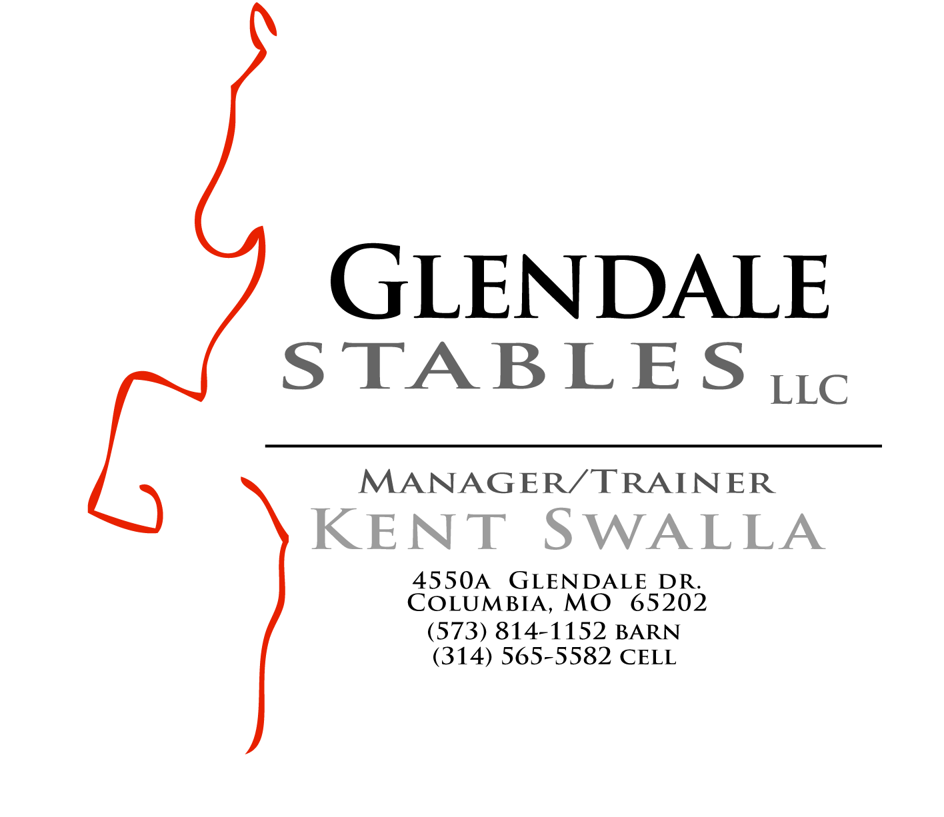

GLENDALE STABLES LLC & GLENDALE FAMILY FARMS LLC
RELEASE AND HOLD HARMLESS AGREEMENT

THE UNDERSIGNED ASSUMES THE UNAVOIDABLE RISKS IN ALL HORSE RELATED ACTIVITIES, INCLUDING BUT NOT LIMITED TO BODILY INJURY AND PHYSICAL HARM TO THE RIDER.

In consideration of being permitted to participate in equine activities, I the undersigned in full recognition and appreciation of the dangers and hazards inherent in equine activities, and during transportation to and from such activities, to which I may be exposed during my enrollment or participation in such activities at Glendale Stables LLC, located in Columbia, Missouri, do hereby agree to hold harmless the Stables, its employees and members and further release them from any liability or responsibility for accident, injury, illness or death to the undersigned, for the period of my enrollment or participation in equine activities at Glendale Stables LLC.

I further agree for myself and on behalf of my heirs, personal representative(s) and assigns to defend, hold harmless, indemnify, release and forever discharge Glendale Stables LLC and all its trustees, officers, agents, and employees from and against any and all claims demands, and actions or causes of action, on account of damage to personal property, personal injury or death which may result from my participation in equine activities or from transportation to or from said activities from cause beyond the control of, and without fault or gross negligence of Glendale Stables LLC, its members, agents, or employees during the period of my enrollment or participation in equine activities at Glendale Stables LLC.

Glendale Stables LLC strongly recommends the use/wearing of protective headgear passing or surpassing current applicable ASTM ( American Society for Testing Measurements) standards with harness secure while riding horses at any time.

FOR THE RIDER: DATE:_________________________

_______________________________________________________________________________________________
RIDER-(PRINT NAME) RIDER- (SIGNATURE) DATE OF BIRTH

________________________________________________________________________________________________
ADDRESS CITY/STATE/ZIP TELEPHONE

FOR PARENT/GUARDIAN IF RIDER IS UNDER 18 YEARS OF AGE:

________________________________________________________________________________________________
PARENT/GUARDIAN- (PRINT NAME) PARENT/GUARDIAN (SIGNATURE)

________________________________________________________________________________________________
ADDRESS CITY/STATE/ZIP TELEPHONE

________________________________________________________________________________________________
E-MAIL ADDRESS OF RIDER OR PARENT /GAURDIAN

